|  |  |  |  |  |  |  |  |
| --- | --- | --- | --- | --- | --- | --- | --- |
| **과제번호** |  | | | | |  |  |
| **Imagination Development Project Application** | | | | | |
| **Type** | **□ H/W project** | **□ S/W project** | | **□ H/W+S/W project** | **□ Other project** |
| **Subsidy** | **100000□ WON** | | **Duration** | | **□ Short □ Long** |
| **Project Name** |  | | | | |
| **Contest Name** | Fill out the name of Contest which will participate | | | | |
| **Supervisor** | **Affiliation** | **Name** | **Contact No.** | | **Note** |
| Computer engineering | Young Sil Lee | Youngsil.lee0113 | |  |
| **Leader** | **Major** | **Student No.** | **Name** | | **Contact No.** |
| Computer engineering | 20152785 | Mohammad Abul Hossain | | [Akash21cent@gmail.com](mailto:Akash21cent@gmail.com) |
| **Participant** |  |  |  | |  |
|  |  |  | |  |
|  |  |  | |  |
| **Participants**  **Oath** | I do solemnly swear that I will faithfully execute the projects if the idea of Imagination development project is selected.  2018. 3. . | | | | |
| (인) | (인) | (인) | | (인) |
| I will submit an application as above to participate in Imagination Development Project.   |  |  |  |  |  |  | | --- | --- | --- | --- | --- | --- | | 2018 | . |  | . |  | . |  |  |  |  | | --- | --- | --- | | Professor : |  | (인) |  |  |  |  | | --- | --- | --- | | Applicant : |  | (인) |   **동서대학교 CK 스마트산업적응형소프트웨어융합창의인재양성사업단장귀하** | | | | | |

I. Imagination Development Project Proposal

|  |  |
| --- | --- |
| **Project Name** | KrishiBangla |

1. Introduction (background, necessity)

Bangladesh is an agro-based country. There are very few apps so far developed in Bangladesh which promote agri-business management and marketing system, especially for farmers in order to marketing their crops. This app supports farmers to communicate with the buyers and making a marketing channel.

Considering the facts, the present project is under taken to develop an application entitled ‘KrishiBangla’ as an ecommerce tool.

2. Goal & Objective

The principle goal of this project is to create a path between farmers and buyer without the interference of any agent. Farmers post their products including possible rate of selling. At the same time buyer can easily find out their desired products and negotiate with the sellers. Through this two-way communication, both seller and buyer will get benefit from this app.

Objectives:

* To develop an application which help to marketing agricultural products

*3.* Related works:

When I was thinking about agricultural-based project on internet and related with my project.

Then I could see that a few application innovate crop market /ecommerce application (India) and these are mentioned bellow:

* AgriApp: which has somewhat related features with my project. My application is marketing based and AgriApp is based on helping of cultivating crops and informative. The major similarity of feature of between these apps is helping of farmers.
* Farmers Ville app: which based on agricultural app. this app features are informative, harvesting crops, news, weather, market location, selling and others.

4. Main Idea: very first my application displays started page where would have two activities, sign up and sign in. After sign up/ login, users can access the Home page where users can see market Trade button and if they click on the button they are able to market where sellers have posted different types of agricultural products and in marketing page will show two activities at top bar which one is Sellers’s Activity and another one is Buyer’s Activity.

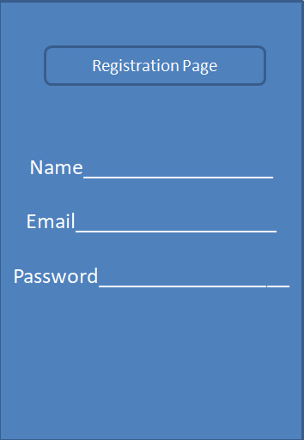

When Sellers Activity is clicked then you can see: Fill the below details shown the screen:

a. Product Details

b. Quantity

c. Description

d. Insert the picture of the product by clicking insert image Button it needs. After Then click on the post button, all the details will be saved. Now slide to left or click on Buyer tab at top. This will redirect to Buyer Activity. Buyer: A list of products available to buy from different sellers registered on the application are shown.

.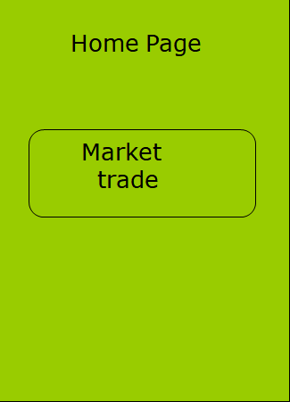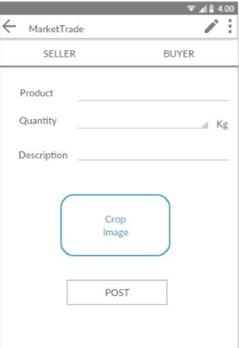

Seller: Fill the below details shown the screen:

a. Product Details

b. Quantity

c. Description

d. Take the picture of the product by clicking the image, which open camera application.

Then click on the post button, all the details will be saved. Now slide to left or click on Buyer tab at top. This will redirect to Buyer Activity. Buyer: A list of products available to buy from different sellers registered on the application is shown. If Buyers click on post of product then it shows chat Activity. Finally, Buyers and Seller will communicate/negotiation through chatting activity.

Click on any product, below details of the seller will be loaded.

a. Name

b. Contact Number

c. Address

Click on contact number, phone call will be placed with the current number. Click on maps, address of the seller will be shown on Google maps. Click on ‘chat with username’, a conversation will be initiated with the seller.

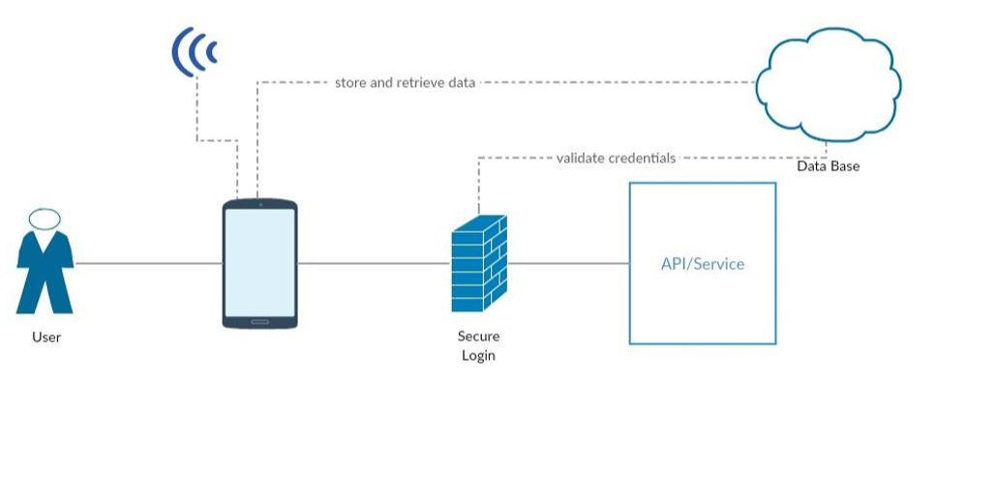

5. Expected effect:

This app will help to the economic development of Bangladesh. Sellers will set the price of their products and market to buyers without any mediator. Buyers will analyze and compare their required products from different sources. It also saves time and reduce unnecessary transportation cost and risk.

6. Members

|  |  |  |  |
| --- | --- | --- | --- |
|  | Student. No. | Name | Role and development field |
| Leader | 20152785 | Mohammad Abul Hossain | Agricultural innovative technology |
| Participants |  |  |  |

6.1 The need for a team project & responsibility of each member

II. Schedule

|  |  |  |  |  |  |  |  |  |  |
| --- | --- | --- | --- | --- | --- | --- | --- | --- | --- |
| **No** | **Contents** | **Schedule** | | | | | | | |
|  | **week 1** | **week 2** | **week 3** | **week 4** | **week 5** | **week 6** | **week 7** | **week 8** |
| **1** | Login and Registration –firebase |  |  |  |  |  |  |  |  |
| **2** | Buyer and Seller Modules |  |  |  |  |  |  |  |  |
| **3** | Editing and Deleting Seller Posts |  |  |  |  |  |  |  |  |
| **4** | Deleting Seller Posts |  |  |  |  |  |  |  |  |
| **5** | Conversation between seller and buyer using Firebase |  |  |  |  |  |  |  |  |
| **6** | Conversation between seller and buyer using Firebase |  |  |  |  |  |  |  |  |
| **7** | Conversation between seller and buyer using Firebase |  |  |  |  |  |  |  |  |
| **8** | Managing user profile |  |  |  |  |  |  |  |  |

III. Project grants execution plan

|  |  |  |  |  |
| --- | --- | --- | --- | --- |
| **Item** | **Detailed Costing of proposals** | **Project Grants** | | **Note** |
|  | **Price (won)** | **Ratio (%)** |
| **Material Cost** |  |  |  |  |
| **Traveling Expenses** |  |  |  |  |
| **Reference Cost** | The Definitive Guide to Firebase: Build Android Apps on Google’s Mobile Platform   * 2.The power of foursquare-API (book) * 3.Head first java(book | )$24,$36,$20 | ) |  |
| **Supplies Expense** |  |  |  |  |
| **Total** |  |  |  |  |

* complete your proposal in more than 5 pages